Event Title: “CAREER PERSPECTIVES IN LIFE SCIENCES AND PHYSICAL SCIENCES: OPPORTUNITIES VS CHALLENGES”

Event Date: 18 June, 2021

Event Venue: Online

Organising unit/ agency/ collaborating agency: Student Counselling Cell

Name of the scheme: NA

Number of students participated in such activities: 90

Summary of Report:( objective, highlights and snapshots like images should be included)

Report
Webinar on
“CAREER PERSPECTIVES IN LIFE SCIENCES AND PHYSICAL SCIENCES: OPPORTUNITIES VS CHALLENGES”
JUNE 18, 2021-Friday (10:50 AM-12:00 NOON)
Organized by Student Counselling Cell
Life Sciences and Physical Sciences offer a wide range of fields based on in-depth study and research in the subject. Employment opportunities are present in both the public sector and private sectors. But at the same time there is excessive competition amongst the candidates and only the best amongst the best are chosen. In this competitive environment, to help our students overcoming their stress while facing these challenges and to make them familiar with the current perspectives in the stated fields, a webinar on the topic “Career Perspectives in Life Sciences and Physical Sciences: Opportunities Vs Challenges” was organised by Student Counselling Cell, Sant Baba Bhag Singh University, Jalandhar, Punjab on June 18, 2021-Friday( 10:50 am-12:00 noon) for the students of Department of Life Sciences and Physical Sciences.
Dr. Manoj Kumar Katual, Life Member of Association of Pharmaceutical Teachers of India (APTI), a Registered Pharmacist from Pharmacy Council and currently working as Head of Institute, Rayat Bahra Institute of Pharmacy, Hoshiarpur-Punjab was the Key note speaker for the event.
The programme commenced with the welcome address by Dr. Anju Sood, Associate Professor and University Student Counsellor.
Dr. Manoj, in his talk, demonstrated the students how to make efforts towards hard work and research, how to be focussed and achieve the set goals. He also discussed the importance of skills, interests and market demand to find an ideal job. He inspired the participants to love the work they are doing and choose the career that fit to their unique talents, aspirations, interests and values. He also highlighted the importance of medical writing, drug safety, technical support, consultancy and document managements. In a nutshell, it was not only a technical session but a motivational session also for the participants.

More than 90 students along with the CODs, and faculty of University Institute of Sciences participated in the webinar. Institute Counselling Coordinators Dr. Amrita Kumari (Co Convenor), Er. Jagteshwar Singh and Dr. Rajwant Kaur also partook in this online programme.
The programme was concluded with the vote of thanks by Co-convener of the programme Dr. Amrita Kumari.

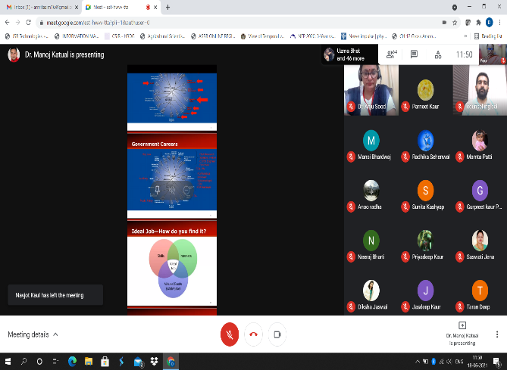 | 